Low Poly Weapons & Shields Pack

by //NoPoly

First of all, I would like to thank you for downloading my asset pack. I hope you can find a good use for them and make some awesome games.

//ASSETS
This pack contains a total of 42 Assets.

- Melee Weapons x 13
- Ranged Weapons x 2
- Shields x 5 (In 5 different colours)
- Quivers x 1 (In 5 different colours)
- Arrow x 1

//COLOURS & UV’s
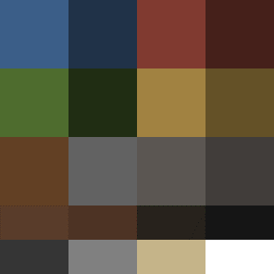
The assets are UV textured with a colour palette in a single PNG image. If you wish to make changes to the colour pattern of the assets, you can do so by moving the UV islands around the colour palette in order to colour the corresponding faces of the mesh. Additionally, you can create your own colour palettes and personalize the assets to fit your game better.
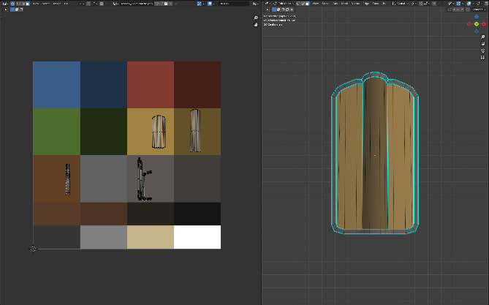

//IMPORTING
Make sure when importing your assets into Unity that you import the Textures folder. Without it, the assets won’t have textures.

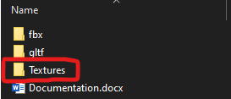

//GODOT USERS
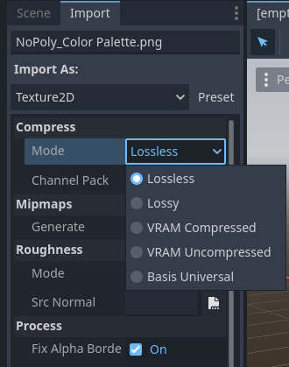
If the textures appear compressed or low resolution, make sure to change Compress>Mode>Lossless. This will generally fix the issue.
You can also select any of the other options. Do what works for you and your project.

//OTHER

This being my first asset pack, I expect there to a list of things that I can improve on in the future.

Please don’t hesitate to reach out to me with any suggestions/criticisms on how I can do better. Game development is hard work and I want the process of using my assets to be as easy as possible.

//CONTACT
Email: nopolystudio@gmail.com
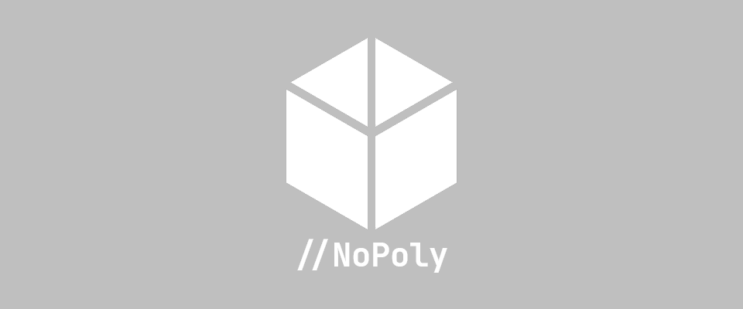
YouTube: www.youtube.com/@nopoly3D

